Project Design Phase-II
Technology Stack (Architecture & Stack)

Technical Architecture:
The Deliverable shall include the architectural diagram as below and the information as per the table1 & table 2
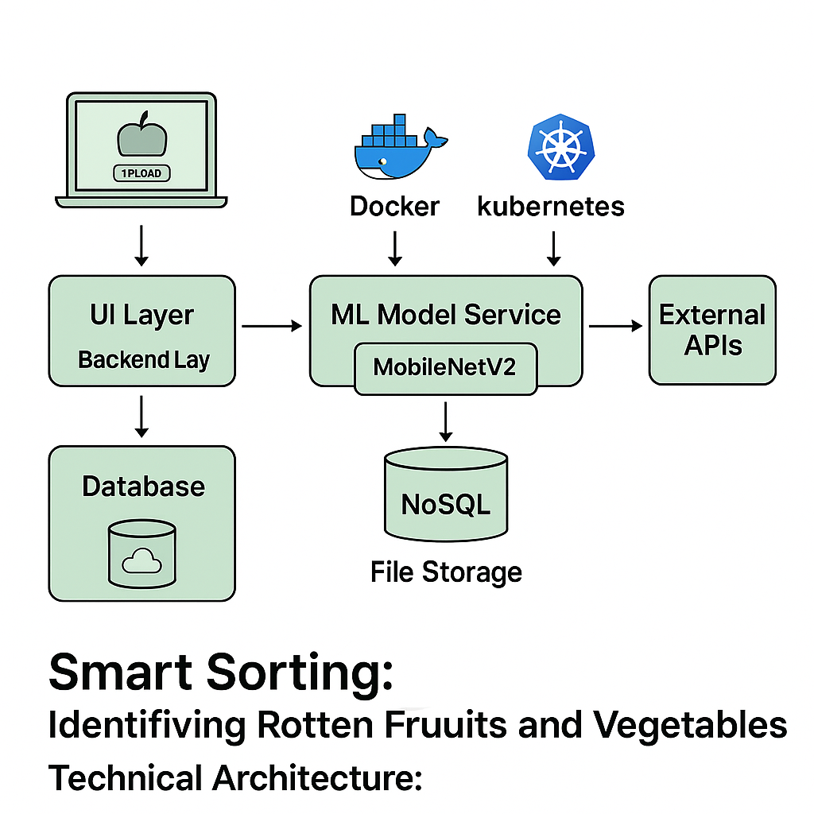

S.No | Component / Characteristic | Description | Technology / Approach
1 | User Interface | Web UI for uploading images and showing predictions | HTML, CSS, JavaScript, React.js
2 | Backend API | Handles requests, user authentication, and prediction calls | Python (Flask or Django REST Framework), REST APIs
3 | Image Processing Pipeline | Preprocess and transform images before prediction | OpenCV, Pillow
4 | Machine Learning Inference | Predict fresh vs. rotten produce using trained models | TensorFlow / Keras, MobileNetV2 Model Serving
5 | Database & Storage | Store user data, logs, and uploaded images | MongoDB, MongoDB Atlas, AWS S3
6 | Security & Authentication | Secure data transfer, encrypt information, manage user access | SSL/TLS, JWT Authentication, IAM Policies
7 | Scalability & Availability | Auto-scaling backend services and load balancing | Docker, Kubernetes, AWS Load Balancer, Auto-Scaling Groups
8 | Performance Optimization | Fast predictions, caching, CDN for static content | Redis Caching, CloudFront CDN, TensorFlow Model Server

